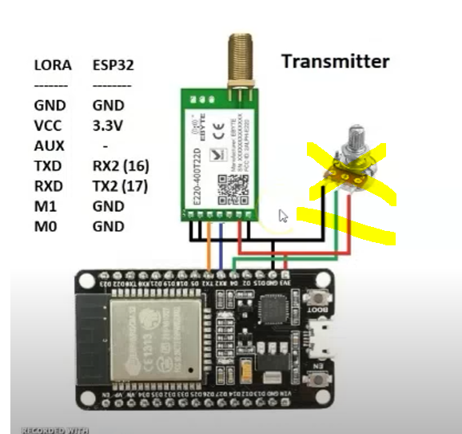Lora setup

Prepare green line, dara e connect ang